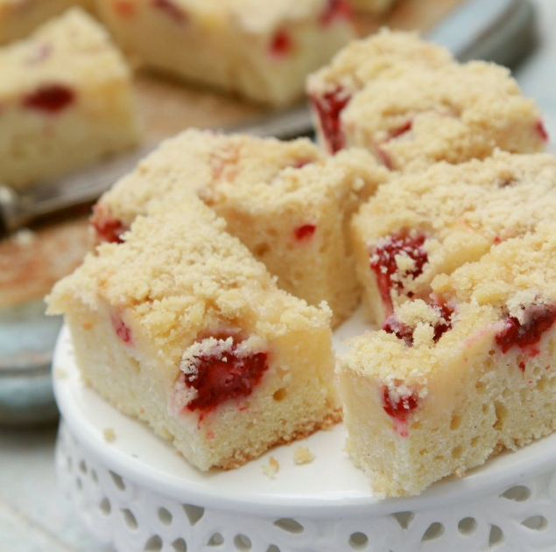
Strawberry and Lemon Traybake

This light, cheerful traybake is perfect for sharing over a cuppa. It’s soft, fruity, easy to slice, and simple enough for companions and clients to enjoy baking together.

Ingredients
- 200g fresh strawberries, hulled and sliced
- 200g self-raising flour
- 200g caster sugar
- 200g soft butter or margarine
- 3 eggs
- Zest of 1 lemon
- Juice of half a lemon
- A little icing sugar for dusting (optional)
Method
- Preheat the oven to 180°C (160°C fan). Line a small traybake tin or square cake tin.
- Beat the butter and sugar together until light and fluffy.
- Add the eggs one at a time, mixing well.
- Fold in the flour, lemon zest, and lemon juice.
- Spoon the mixture into the tin and smooth the top.
- Scatter the sliced strawberries evenly over the surface.
- Bake for 25–30 minutes, until golden and springy to the touch.
- Leave to cool, then dust with icing sugar if you like.

